EQUATOR RESOLUTION
Engineering Handoff — Workplace & HR vertical

Technical Architecture & Data Specification
System design, sealed POSH architecture, data model and API contract

Workplace & HR Dispute Resolution vertical
July 2026 · Draft for legal sign-off · www.equatorresolution.com

Purpose & scope
This document specifies the architecture for the workplace & HR vertical. It is delivered with `openapi_wp.yaml` (22 endpoints, 5 of them on a sealed POSH surface) and `schema_wp.sql` (23 tables across two schemas, 9 enumerated types, 15 guard constraints). The design principle that shapes everything else is that POSH data is not ordinary case data.
Three rules enforced in code, not policy
(1) Sealed POSH. POSH complaints live in a separate database schema with a separate role and no join path to ordinary case data (POSH Act s.16). (2) Section 10 limits. Conciliation is rejected by a database constraint unless it was requested by the aggrieved woman and asserts no monetary basis. (3) Statutory dues. A settlement asserting waiver of gratuity, PF or ESI is refused by both the API (422) and a CHECK constraint.

1. Logical architecture
Service | Responsibility | Schema
Identity & KYC | Party identity, DPDP consent, roles and scopes | public
Case & workflow | Case lifecycle, triage, SLAs | public
Employer | Employer profile, panel SLA, POSH subscription, compliance status | public
Panel & appointment | Neutral roster, conflict checks, structural-conflict disclosure | public
Sessions | Scheduling, joint/caucus/shuttle, sealed caucus notes | public
Settlement & F&F | Gratuity and F&F computation on the Code on Wages definition; MSA | public
Escrow & payments | Instructions, milestone release conditioned on relieving and asset return | public
POSH service | Complaint, IC constitution, s.10 conciliation, inquiry clock, annual report | posh (sealed)
AI service | Route/rights assistant with POSH-safety routing | public (redacted logs)
Audit & reporting | Hash-chained audit across both schemas; MIS | public

2. The sealed POSH architecture
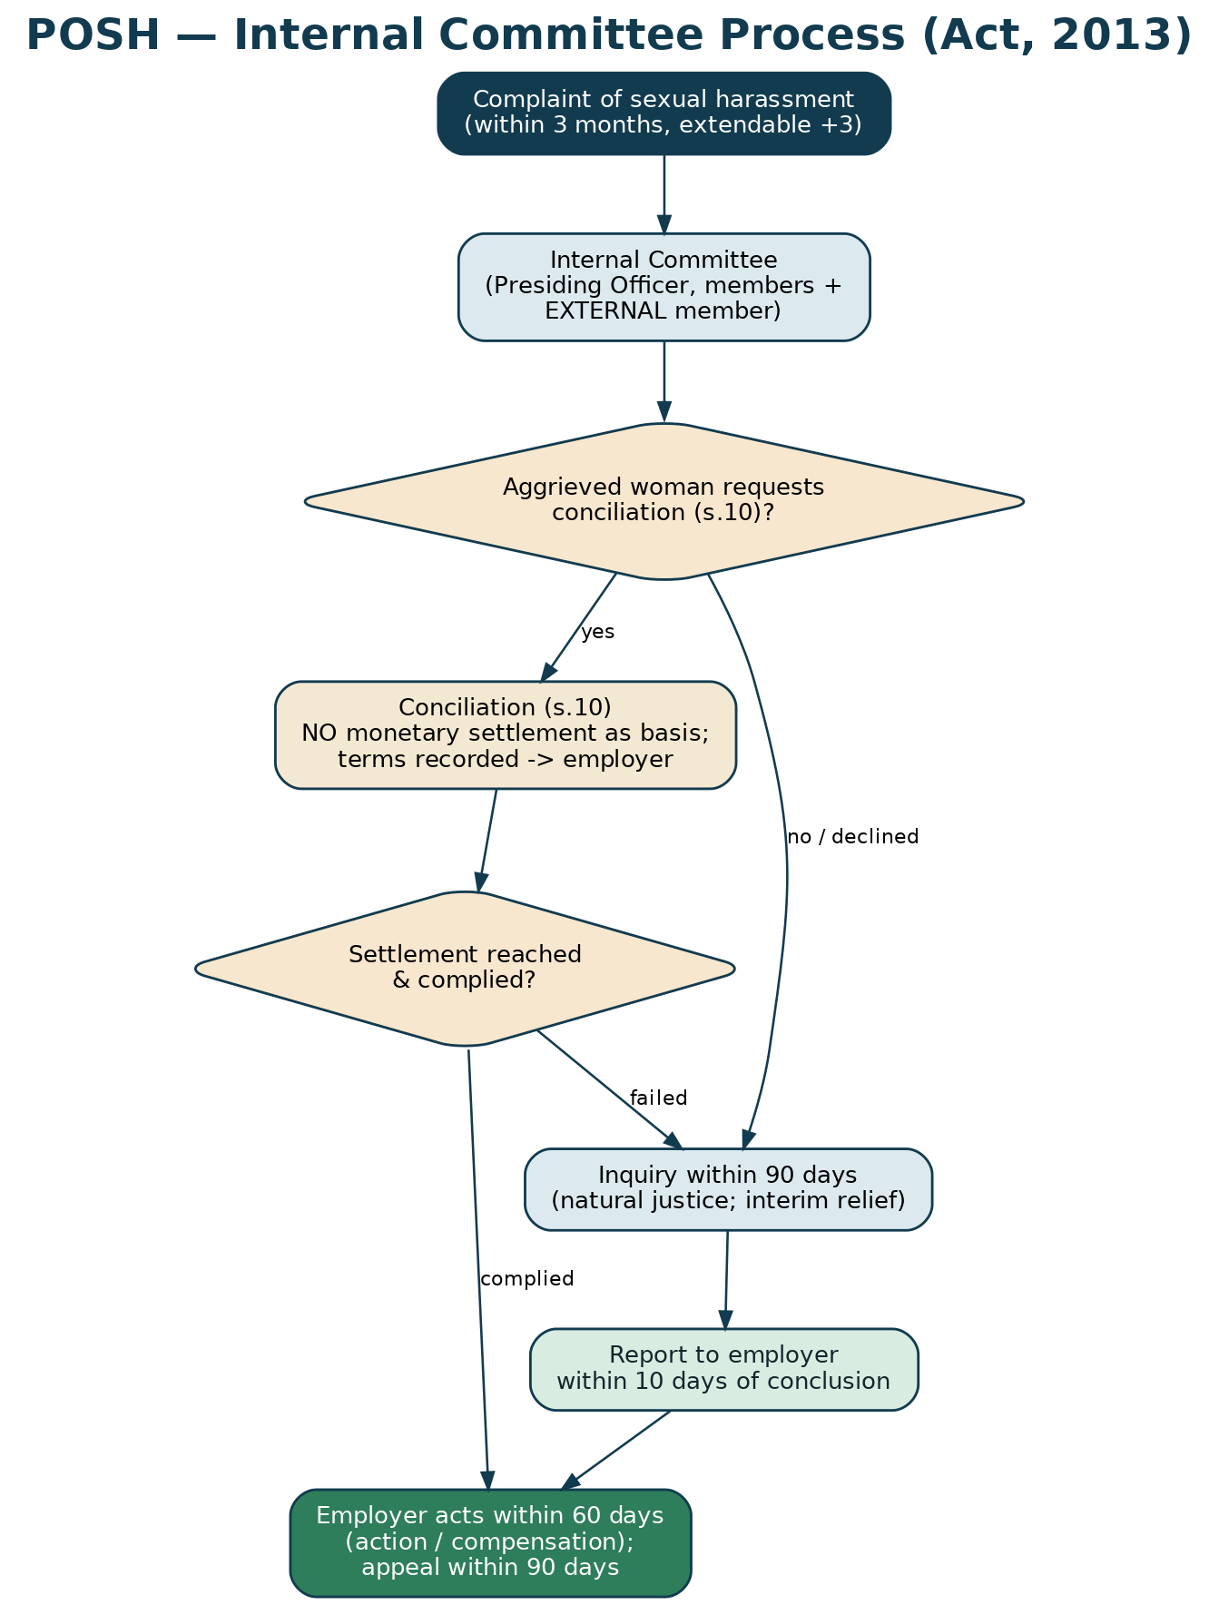
Figure — the statutory process the sealed surface must support.
- POSH data is stored in schema `posh`, granted to a distinct database role. Ordinary application roles hold no privileges on that schema.
- `posh.complaint.employer_id` is deliberately not a foreign key — there is no query path from an ordinary case to a complainant's identity.
- Identity, respondent and particulars are stored as ciphertext (`BYTEA`), decrypted only in the POSH service.
- `wp_case` carries an `is_posh` flag with a CHECK constraint preventing a POSH matter from ever entering an ordinary mediation state.
- The API refuses to create a POSH matter as an ordinary case (422) and requires a `posh` scope for the sealed endpoints (403 otherwise).
- Audit events record which schema was touched, so access to POSH material is separately reviewable.
3. Statutory rules as constraints
Rule | Where enforced | Behaviour
IC must include an external member (s.4) | `posh.internal_committee` CHECK | Insert fails without `external_member_id`
At least half the members women (s.4) | `posh.internal_committee` CHECK | Insert fails if women < half
s.10 only at the woman's request | `posh.conciliation` CHECK + API 422 | Cannot record IC- or respondent-initiated conciliation
No monetary basis for s.10 | `posh.conciliation` CHECK + API 422 | `monetary_basis` must be false
Inquiry within 90 days | `posh.inquiry` CHECK + generated `due_on` | Conclusion beyond 90 days rejected; clock exposed via API
Report within 10 days; employer acts in 60 | `posh.employer_action` generated column | Deadlines computed, not typed
Statutory dues never waived | `wp_settlement` CHECK + API 422 | Settlement refused if waiver asserted
Structural conflict disclosed (Rule 7) | API 409 on appointment | Appointment refused unless disclosed

4. The Code on Wages in the data model
`employment_record` carries `monthly_wages` (basic + DA + retaining allowance) and `wages_pct_of_ctc`. The F&F endpoint returns a `wageDefinitionWarning` where that percentage is below 0.50, because the Code on Wages requires the excess to be added back for statutory computation. This is the single most common source of under-computed gratuity, and the platform surfaces it rather than silently reproducing the employer's arithmetic.
5. Security, data protection and delivery
- Encryption — TLS 1.2+; AES-256 at rest; field-level encryption for POSH and caucus material.
- Access — RBAC plus a separate `posh` scope and database role; step-up authentication for sealed data.
- Audit — append-only, hash-chained, recording the schema touched.
- DPDP — consent capture and withdrawal, minimisation, masked identifiers, retention driven by `wp_retention_policy`.
- Delivery — dev/staging/production; IaC; CI/CD with security and AI-evaluation gates; staged rollout to a pilot employer before general availability.

